Under Bench Town Water Filter System.
Parts List: Qty:

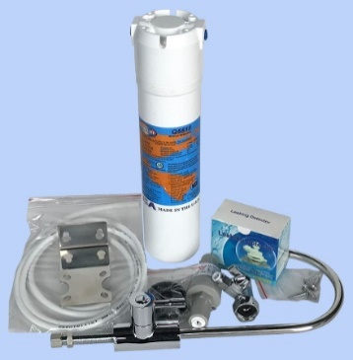
Q-Series Head Unit and Stainless-Steel bracket 1
Mounting Screws 4
Omnipure Filter Cartridge. Q5515 1 micron Carbon Block 1
Chrome 15mm BSP female to 15mm BSP Connector (SV-5) 1
Pressure Limiting Valve. (PRV 14 QC) 1
2 metres of ¼” OD Low Density Polyethylene (PIPE ¼”) 1

Installed Size: Height = 45cm x W = 8cm x D 12cm

Assembly Instructions:

- Turn main water supply off, then turn on a tap to remove the water pressure before disconnecting any water pipes.
- Fit the Stainless-Steel bracket to the Q-Series Assembly with the mounting Screws supplied then attached, to the desired mounting position, with the water flowing in the chosen direction. The bracket can be removed and turned 180° to suit the desired flow direction.
- Disconnect the cold water supply flexi hose from the 15mm BSP water inlet at the back of the cabinet and connect the SV-5 Tap to the male connection and reconnect the cold water supply to the SV-5 fitting Do Not turn the mains water back on yet.
- Mount the Bench Tap and tighten into position.
- Cut a length of ¼” OD tubing to connect the Bench Tap to the outlet on the Filter Housings, allowing for bends.
- Push the tube support into the tube and connect to the Bench Tap. Do not overtighten. Take the other end of the pipe and push firmly into the quick connect fitting on the filter housing outlet.
- Connect the cut length of ¼” OD tubing to the SV-5 Tap .
- Cut a suitable length of ¼” OD tubing and connect to the Pressure Limiting valve Inlet.
- Cut a suitable length of ¼” OD tubing and connect the Pressure Limiting valve outlet to the Inlet of the filter housings.
- Turn on the water supply and run until the air is gone, turn off faucet and check for leaks. Once you have checked and fixed any leaks ensure the mounting surface is dry then fix the Leak Stop Valve to the bottom of the cupboard.
- Prior to using the water from the System, run the water through the system for 10 minutes to wash any carbon dust that may be present in the Ceramic filter

Changing Filters Cartridges:
- The Q5515 Cartridges should be changed every 12 months or more often if the water supply slows due to high sediment loading or has had high usage.
- To remove the cartridges, turn the water supply off on the SV-5 valve and turn on the water filter to remove all the pressure from the Filter Cartridge.
- Put a large towel under the filter housings so no water gets in contact with the leak stop valve as this will restrict the water flow to the filter when turned back on. Turn the base of the Filter Housing to the left (in an clock wise direction).
- Discard the old cartridge,
- Turn on the water supply and run until the air is gone, turn off faucet and check for leaks.
- Prior to using the water from the System, run the water through the system for 10 minutes to wash any carbon dust that may be present in the Ceramic filter.

